MongoDB Assignment B
Haadiya Hasan Faruqi

Database : University
Collection Name : Students
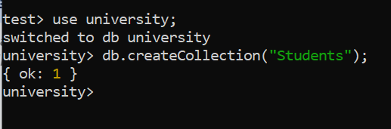

Adding multiple entries inside of the collections with fields including : name, age, department and grades and displaying them.
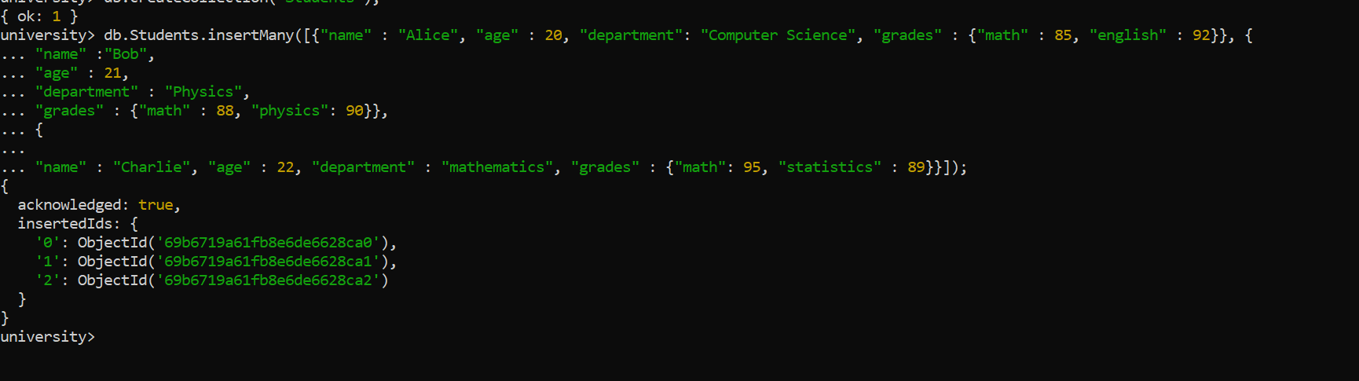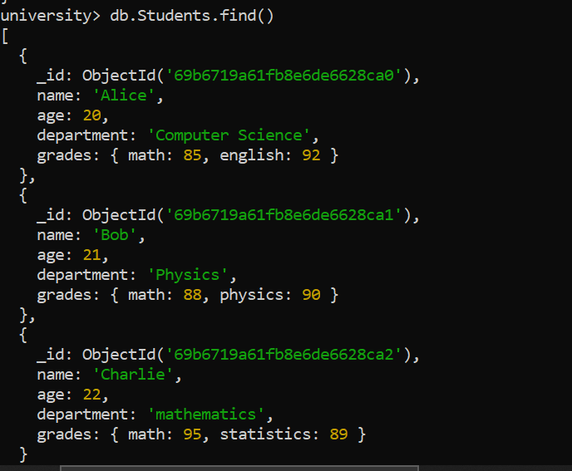

2. Query to display all students who are in the Computer Science department:-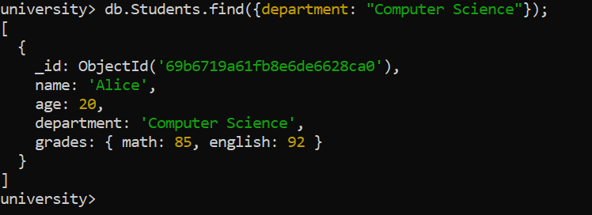

3. Query to update the grades of a student named Alice by adding a new subject programming with a grade of 93:-
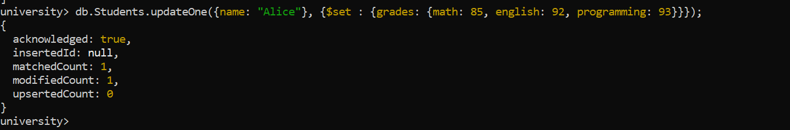

4. The query to increment the age of all students by 1 :-
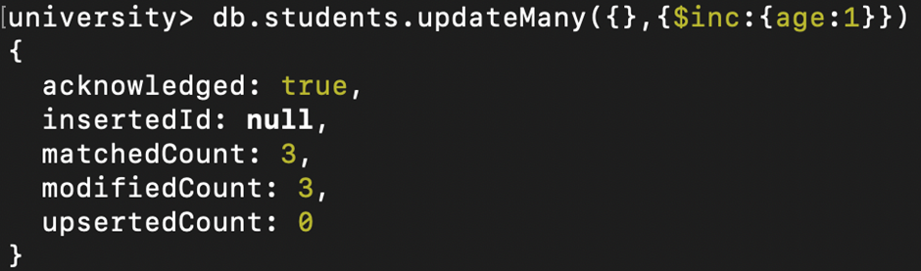

5. To delete all students who are 23 years old:-


6. To create an index on the name field of the students collection.
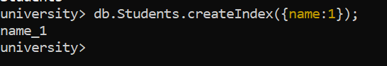

7. Aggregation query to group students by their department and calculate the average age in each department.
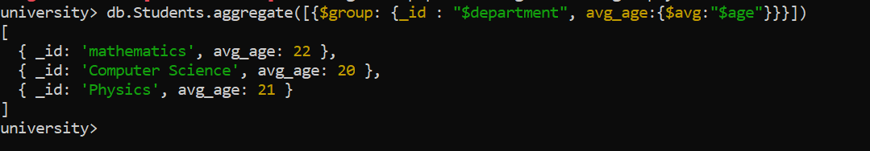

8. Query to find all students who have scored more than 90 in any subject.
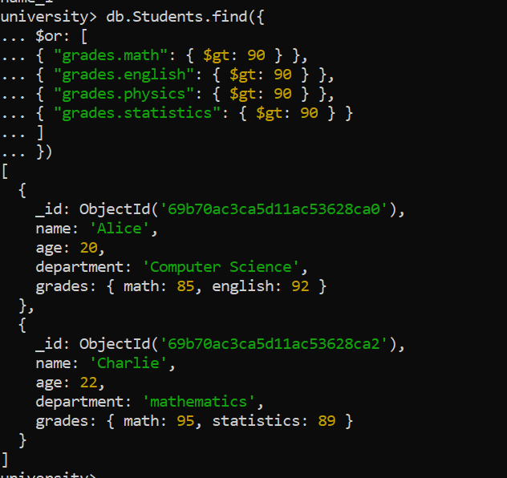

9. Query to add a new field graduated set to false for all students who are in the Mathematics department.
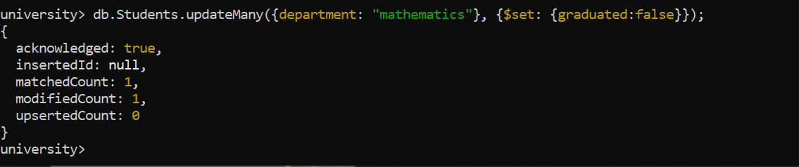

10. To retrieve only the name and department fields for all students, excluding the _id field we perform this command:-
